**Drawing Shapes using VertexArray**

https://www.youtube.com/watch?v=hnjhCFA4GnM&list=PLRtjMdoYXLf776y4K432eL_qPw4na_py3&index=29

#include "stdafx.h"

#include "SFML/Graphics.hpp"

#include <iostream>

#include <windows.h>

int main()

{

sf::RenderWindow window (sf::VideoMode(600, 600), "SFML works!");

sf::Vertex point;

point.position = sf::Vector2f(300,300);

point.color = sf::Color::Red;

sf::VertexArray line(sf::Lines, 2);

line[0].position = sf::Vector2f(200, 150);

line[0].color = sf::Color::Blue;

line[1].position = sf::Vector2f(400, 90);

// line[1] = point; copies position and color

line[1].color = sf::Color::Green;

sf::VertexArray triangle(sf::Triangles, 3);

triangle[0].position = sf::Vector2f(20,20);

triangle[0].color = sf::Color::Red;

triangle[1].position = sf::Vector2f(200, 20);

triangle[1].color = sf::Color::White;

triangle[2].position = sf::Vector2f(150,150);

triangle[2].color = sf::Color::Blue;

sf::VertexArray quad(sf::Quads, 4); // quad means 4

quad[0].position = sf::Vector2f(200, 400);

quad[1].position = sf::Vector2f(160, 450);

quad[2].position = sf::Vector2f(180, 500);

quad[3].position = sf::Vector2f(220, 500);

while (window.isOpen()) {

sf::Event event;

while (window.pollEvent(event)) {

switch (event.type) {

case sf::Event::Closed:

window.close();

break;

}

}

window.clear();

window.draw(line);

window.draw(triangle);

window.draw(quad);

window.display();

}

}

**Result**

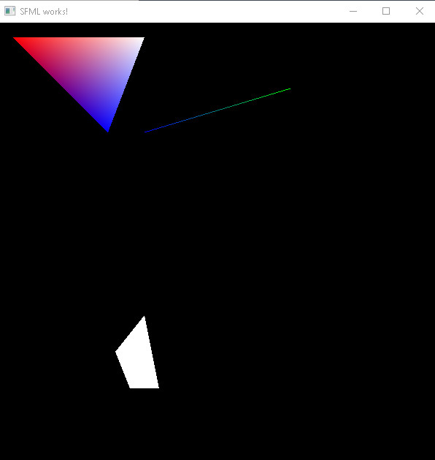

**Important points:**

* You can assign a Vertex object to a member of VertexArray object; assigns point position and color